Keeping people safe
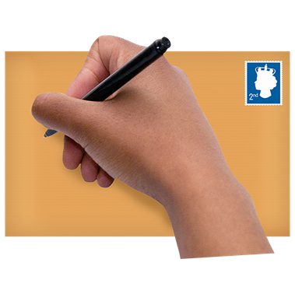 | Some organisations are worried about how safe older people, autistic people and people with people with learning disabilities/difficulties, cognitive disabilities or mental health support needs are in hospitals and care homes at the moment.  They are writing a letter to the CQC (the care quality commission) about this.
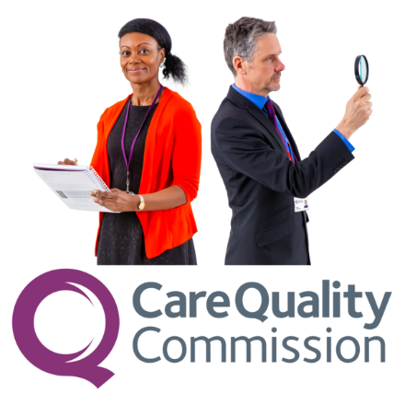 | The CQC’s job is to check if people in hospitals, care homes and other services are being looked after well.  These organisations are worried about older people, autistic people and people with learning disabilities/difficulties, cognitive disabilities or mental health support needs, who are staying in these places.  They are at high risk for abuse, violence, over medication and neglect.
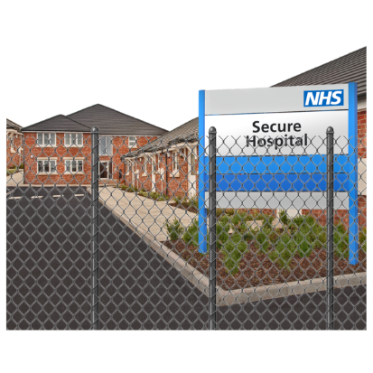 | People are sometimes deprived of their liberty in these places and can be vulnerable with nobody checking on them.  Families often live far away from where their loved ones are staying so the CQC might normally be the only people checking to make sure they are safe.
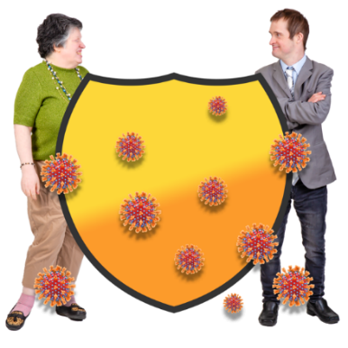 | Because of coronavirus families and friends are also not able to visit their loved ones in these places now even if they do live close enough.  A group of organisations are getting together with Leigh Day, who are lawyers, to send a letter to complain about the CQC.
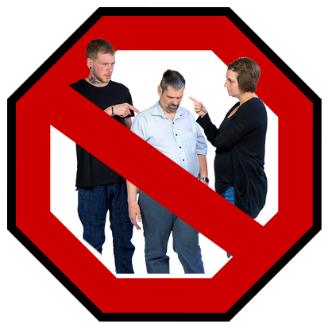 | The CQC have said that because of coronavirus they are going to stop checking on these places.  They will only visit if someone says there is a problem.  The organisations are worried people will not be able to complain to the CQC if they do not make their normal visits.
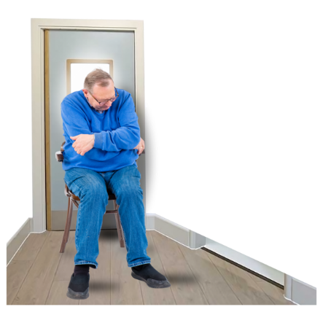 | The group feels the CQC, not checking, will put people at risk of being hurt or abused.  People will not be able to speak to anyone outside the hospitals or care homes they are staying in.  The letter is arguing that this decision by the CQC is against the human rights of people in hospitals and care homes.
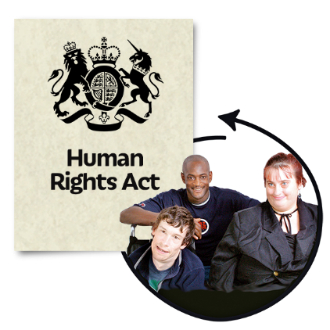 | They have said it breaks the Human Rights Act 1998, the Health and Social Care Act 2008 and the Equality Act 2010.  Organisations are asking the CQC to change their minds and do inspections so that they can make sure people are safe.
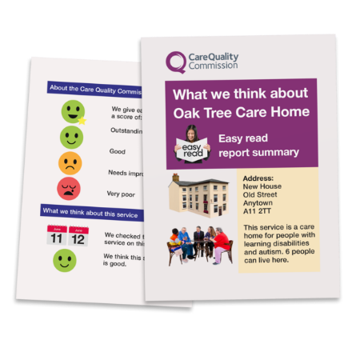 | When the CQC does inspections they can rate an organisation as:  - Outstanding – it’s really good  - Good – doing well  - Requires improvement – not doing so well and they are told how to become better  - Inadequate – doing badly, action is taken by the CQC to make them do better or close them.
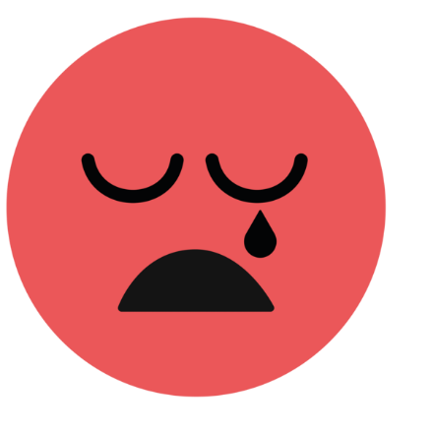 | The letter argues that the CQC should visit the services which they have said are inadequate first and requires improvement.  It is also very important they check services where people have Coronavirus and the services that they have not visited for a long time.
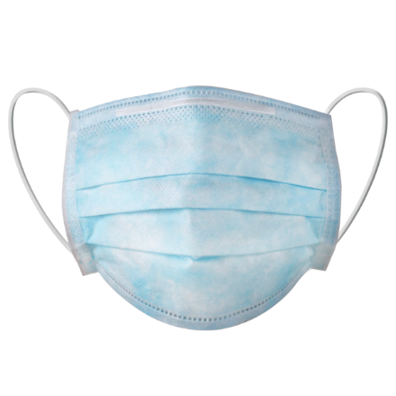 | They also want them to visit services where patients or residents can’t speak to them on the phone or video call.  The letter advises the CQC give their inspectors special clothes and masks to protect themselves from the coronavirus called PPE and give training to inspectors on being safe on visits.
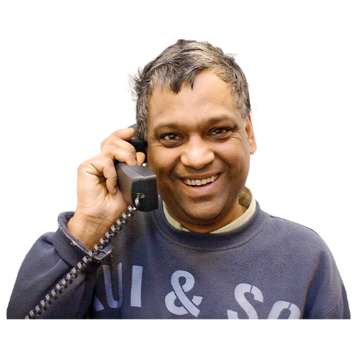 | They also want the CQC to ask services to say how and how often they are supporting people to stay in touch with their family.  The letter also suggests sending services, a good practice guide on how to support residents to keep in touch with their family.
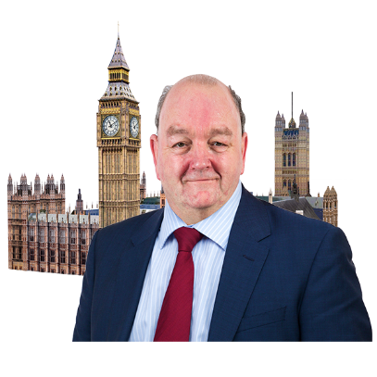 | This letter has been sent to:  - Ian Trenholm Chief Executive of the CQC  - Matt Hancock MP, Secretary of State for Health and Social Affairs  - Jeremy Hunt MP, Chair of the Health and Social Care Select Committee  - Harriet Harman MP, Chair of the Joint Human Rights Committee
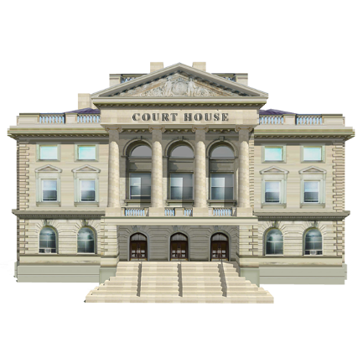 | If the CQC do not change their minds the group will take them to court.  The letter asks the CQC to continue to do their job and do inspections because everyone wants patients to be safe.

